Name:

1. Prove the following

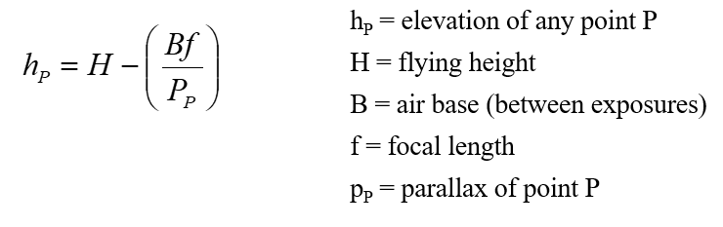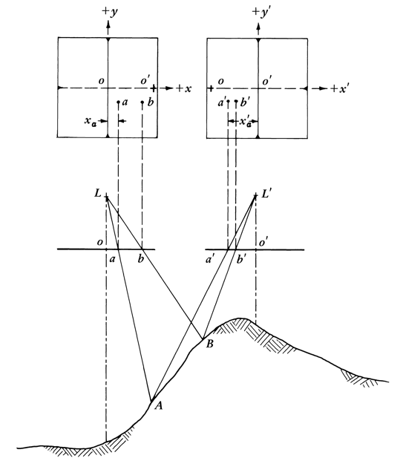

1. Explain the following equation

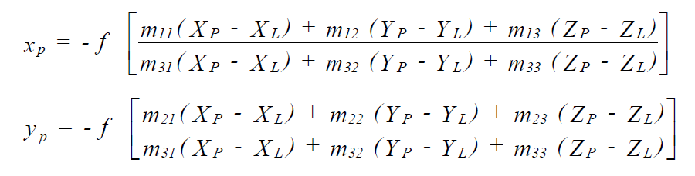

1. Explain relief displacement